# Creating a screen capture

For any of the following you will need access to a laptop or phone and a microphone (this could be built in to your device). A webcam is optional.

## **Powerpoint**

Depending on the version of powerpoint that you have, you can create a screen cast or video recording of your presentation.

### Powerpoint 2010

1. Open your presentation in Powerpoint.
2. Click or tap on the “Slide Show” tab and select “Record Slide Show” and choose “Start recording from Beginning”

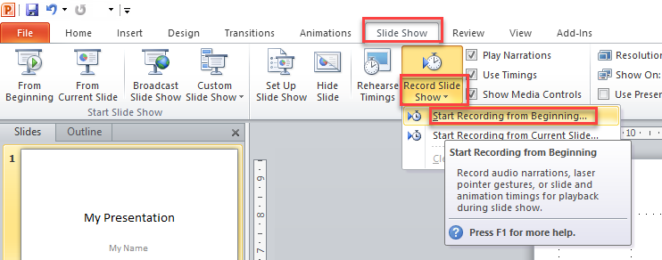

1. Select what you want to record. Narration must be selected to capture your audio. If you have animations on your slides, ensure the first box is ticked.

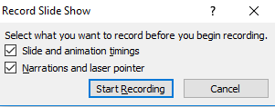

1. Talk over your slides as you would in a live presentation. Use the “Next” arrow to move on to the next slide, and the “pause” button to pause the recording.

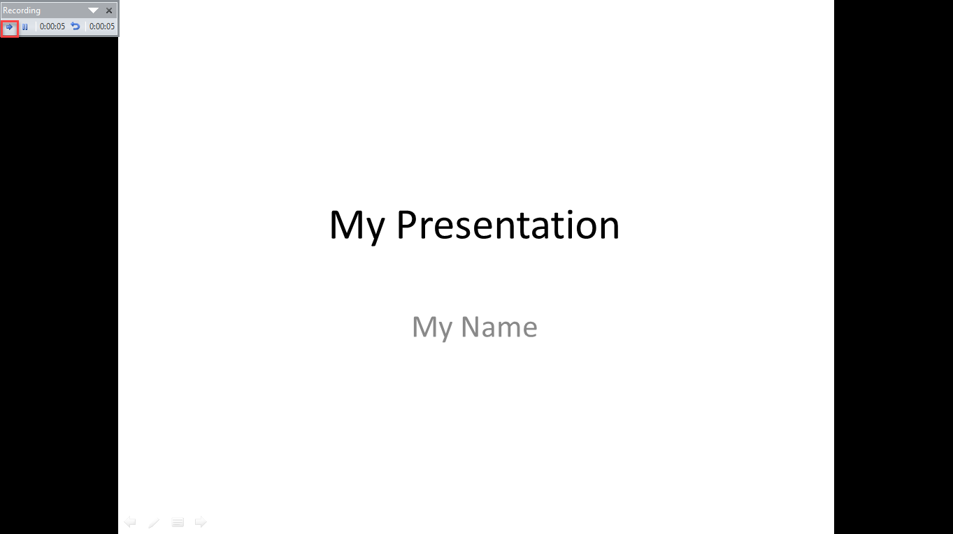

1. When you have reached the end of your presentation, the recording will stop. You will then see a summary of your slides and their narrations.



1. When you have finished, go to “File” and “Save as” then select “Windows Media File .wmv” as the file type and click or tap “Save” to confirm.

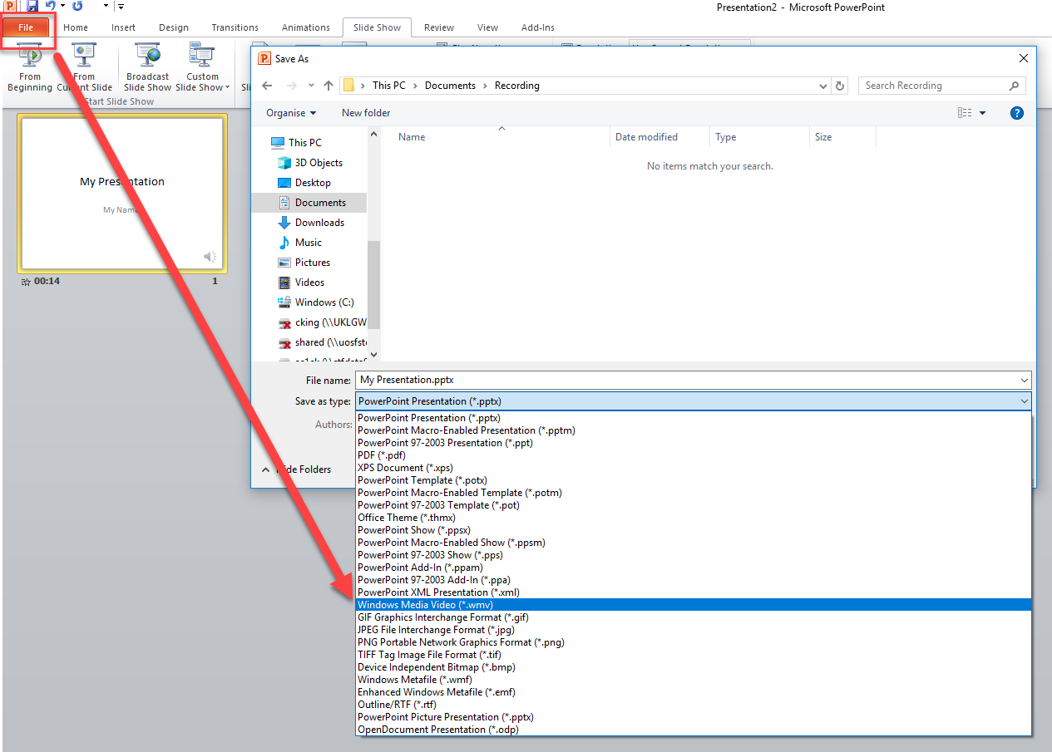

### Powerpoint 2016 or later

1. In Powerpoint 2016 or later, open your presentation and open the “Insert” tab.
2. Select “Screen-Recording”.

The Screen Recording button on the Recording tab in PowerPoint 2016

1. Click or tap “Select Area” and you will you see the cross-haired cursor Cross haired cursor . Click and drag to select the area of the screen you want to record.

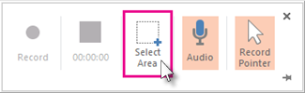

1. Click “Record” to start your recording.
2. To control your recording:
   1. Click Pause to temporarily stop the recording
   2. Click Record to resume recording
   3. Click Stop to end your recording

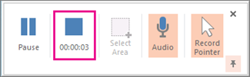

1. When you are finished recording, save your presentation by clicking or tapping “File” then “Save”. The recording is now embedded on your slide.
2. To save the recording itself as a separate file on your computer, right-click the picture on the slide that represents the recording, and select Save Media as. In the Save Media As dialog box, specify a file name and folder location, then click Save.